Evaluation of Radio Telemetry for Quantifying Home Ranges and Susceptibility of Road Encounters of 3 Snake Species in the White Lake Basin, BC.

By

Jollee Perrier

A Research Essay Submitted for Undergraduate Research Experience Award
(U-REAP) Fall 2022

In the Department

of

NATURAL RESOURCE SCIENCES

FACULTY OF SCIENCE

at

THOMPSON RIVERS UNIVERSITY

BY JOLLEE PERRIER

Abstract
Anthropogenic activities are causing major threats to herpetofauna worldwide. The impacts of roads are a significant threat to snakes, where extinction rates increase through direct mortality and population fragmentation. However, not all species are affected to the same degree: snake species differ in morphology, home range, movement patterns, and behaviour that influence the likelihood of interacting with roads. Within the White Lake Basin in Southern Okanagan BC, roads pose a substantial threat to Western Rattlesnakes, Great Basin Gopher snakes, and Western yellow-bellied racers; these are species with significantly different life histories, and not all species have been well studied in relation to home range and road behaviours. My study has two objectives: 1) Understand how these 3 different snake species differ in home range and movement patterns, and 2) How do these factors influence their susceptibility to road encounters and mortality. I tracked 8 adult snakes using radiotelemetry throughout their active season and determined home ranges, movement patterns, habitat usage, and interactions with roads. Results show that habitat selection between species was consistent. The racers and gopher snakes predominantly used open grassland over 80% of their summer range, while rattlesnakes used about 55% while the other portion being open coniferous, riparian, and gullies. There were 2 gopher snakes and 1 rattlesnake that crossed a road once, and 2 racers and 1 gopher snake that used roadside ditch as habitat. In addition to road interactions, den proximities to roads were not clearly linked to the degree of road interaction that the animals showed. Continuing data collection for long term road mortality data and snake movement is critical for creating road mortality mitigation management decisions.
Table of Contents
Abstract i
Table of Tables iii
Table of Figures iii
Introduction 1
Methods 2
Results 4
Great Basin Gopher snake 5
Western Rattlesnake 5
Western Yellow-bellied Racer 6
Discussion 6
Great Basin Gopher snakes 6
Western Rattlesnakes 6
Western Yellow-bellied Racers 7
Conclusion 8
Literature Cited 9
Appendix A 11
Telemetry maps 11
Great Basin Gopher Snakes 11
Western Rattlesnakes 12
Western Yellow-bellied Racers 14

Table of Tables
Table 1. Comparing 2 snake species and their dens distance to the nearest road and if crossed a road 4
Table 2. The proportion of habitat a snake used that observed during each tracking event 5
Table 3. Physical descriptions and telemetry information of each snake 18

Table of Figures
Figure 1. Telemetry for Sadie the Gophersnake. The end of the red and start of the black line shows where she was last located, and the black star indicates location of signal of confirmed mortality. 13
Figure 2. Telemetry of Blondie’s movement from leaving the den and into summer range. 13
Figure 3. Telemetry of Marisol’s movement from leaving the den and into summer range. 14
Figure 4. Telemetry of Tuco’s movement from leaving the den and into summer range. 14
Figure 5. Telemetry of Teddy's movement from leaving the den and into summer range. 15
Figure 6. Telemetry of Gene's movement from leaving the den and into summer range. 15
Figure 7. Telemetry of Chana's movement from leaving the den and into summer range. 16
Figure 8. Telemetry of Mung's movement from leaving the den and into summer range. 16
Figure 9. Telemetry of Pinto's movement from leaving the den and into summer range. 17

Introduction
Wildlife populations globally are decreasing in size and largely driven by an unprecedented rate of anthropogenic threats including habitat loss, invasive species, and climate change. Among the groups most at risk are herpetofauna; globally 41% of amphibians and 21% of reptiles are listed as threatened under IUCN (2022), and over 50% of amphibian and reptile species in British Columbia (BC) are listed as species of conservation concern (MoE 2020). The most significant threat to reptiles is road mortality (CHS 2022) and therefore, must be a priority action of mitigation for the recovery/stability of these species. BC is in preliminary development of roadside mitigation measures for amphibians and reptiles (MoE 2020). Roadways are impacting wildlife populations in BC, directly from road mortality, and indirectly by acting as barriers for gene flow leading to lower genetic diversity and consequently, higher risk of extinction (Frankham et al. 2002, Clark et al. 2010).

Road ecology on snakes is particularly relevant within the South Okanagan region of BC. Winton et al. (2020), found that road mortality is a major threat to the future persistence of Western Rattlesnakes (Crotalus oreganus oreganus) population in the White Lake basin. Understanding this community requires additional research on the behaviours associated with the current measures for effective project planning mitigation effectiveness (Rytwinski et al. 2016, Macpherson et al. 2021). Snakes have dynamic interactions with their environment and are respectively linked to the extent of their home range and habitat selection (Van Moorter et al. 2015, Viana et al. 2018). Within their home ranges they rely on communal hibernating sites called hibernaculum and use scent trails when moving throughout their ranges for mating, foraging, and help in finding hibernacula location especially for juveniles (Moe 2022, Muellman et al. 2018, B.C Reptiles and Amphibians 2022). Therefore, creating mitigation strategies must recognize the extent of the animal's home range because it impacts the likeliness of encountering roads, understanding species-specific behaviour, and life history traits (Seilder et al. 2018). Andrews et al., (2005) saw that snake species differed in road avoidance, where smaller snakes had higher levels of road avoidance and venomous snakes crossed. Studies have also seen that snakes interact with roads due to their possible attraction to the surfaces for thermoregulation and if it intersects through the extent of their home range (Waye and Shewchuk 2002; Wind 2018a). Studies done by Fortney et al., (2012) and Rouse et al., (2011), revealed the importance of snake’s hibernacula location because it influenced the susceptibility of snakes on roads and additionally, Degregorio et al., (2010) found that road mortality was related to life history traits and activity patterns such as dispersal movements. Knowledge of species-specific behaviour on home range and movement patterns is still lacking, specifically on species of conservation concern, e.g. Great Basin Gopher snake (Pituophis catenifer deserticola), and Western Yellow-bellied Racer (Coluber constrictor mormon) in the South Okanagan region of British Columbia.

The Okanagan Valley contains peripheral northern habitat for species including these 3 snake species of interest (Kirk et al. 2021). Peripheral populations can be critical components for conservation as they contain areas of speciation and genetic diversity (Fraser 1999). White Lake Grassland Protected Area is in the Southern Okanagan and is an acknowledged ‘hot spot' for conservation: it supports 57 species at risk (under SARA), 27 red- and blue-listed plant communities, and sacred cultural and traditional use sites by the Syilx people (NTBC 2021). Furthermore, the rattlesnake, gopher snake, and racer occupy the same habitat within this area, providing a significant opportunity for comparing home range and road encounter rates. Anthropogenic factors are pressuring snake persistence in the White Lake basin from 2 roads intersecting and causing a lack of connectivity of their habitat. This is causing road mortality when they interact with during their movements to and from their hibernacula and summer range. In 2018, eight eco-passages and directional fencing were installed to aid in habitat connectivity to decrease road mortality by allowing safe passage for snakes under the road. Although the effectiveness of this mitigation technique has not yet been determined road mortality and observing effectiveness continues in the White Lake basin. Therefore, the goals of my study were to determine the following, 1) Understand how these 3 different snake species differ in home range and movement patterns, and 2) How do these factors influence their susceptibility to road encounters and mortality.

Methods
This study is a continuation of a long-term monitoring project of snake populations within the White Lake Basin (South Okanagan BC, Canada) established in 2016. Data will be collected from April to September of 2022 within and around the White Lake Basin, South Okanagan, British Columbia. Adult rattlesnakes (n=4), gopher snakes (n=4) and racers (n=4) will be captured, processed and tracked through radiotelemetry to determine the ranges and movement patterns for each species. The snakes will be caught during early spring at their dens. The dens selected will be in proximity of a road. This study will be incredibly useful as all three species will be tracked simultaneously so that weather influences will be consistent for all animals. Upon initial capture of chosen snakes, I will process them by recording sex, weight, age, species, length, and general overall condition. They will only be processed upon initial capture, mid-season, and before ingress. Snakes will be taken to a certified vet for transmitter implantation; the snakes are only allowed to be in captivity for maximum 7 days and given 1-2 days recovery before released at site of capture. Animals will be tracked twice a week where location, habitat, air and ground temperature and humidity, cover, and behaviour will be recorded (Table 3). Habitat type is determined on the main ecosystems present. The radius to determine which ecosystems to choose was approximately within 10-20m of the snake. For example, if a snake is using open grassland but there is riparian habitat within 10-20m, then there will be 2 habitats recorded for being used. The habitat types used are transformed into proportion percentages from the total of each tracking event. I will also be recording how often snakes cross or interact with a road. The racers will be caught mid-July before their current transmitter batteries die and have them replaced with same procedures as initial implant. At the end of the study all the snakes will be recaptured for transmitter removal. Telemetry data will be processed using Microsoft Excel and Google Earth to transform coordinates into home range maps.

Results
The rattlesnakes on average compared to other species traveled the farthest away from their dens (1054m). When comparing total distance traveled, racers traveled an average of 3705m, which is 2.1 times farther than the rattlesnakes and 3.2 times farther than racers total distance. It was observed that 3 out of the 8 snakes, 2 gopher snakes and 1 rattlesnake crossed one road (Table 1). The gopher snakes chosen were 2 females and 2 males. One of the female Gopher snake’s “Sadie”, died of mortality from a bird of prey on approximately June 29, 2022. This was determined by the signal was visibly from a bird nest in an Interior Douglas Fir tree (Pseudotsuga menziesii var. glauca) (Figure 1). It’s also to note that concluding results for the racer and gopher snakes lack because, telemetry was continued into late September, early October 2022, because I was unable to capture them when the rattlesnakes were. (Table 1A).

Table 1. Comparing 2 snake species and their dens distance to the nearest road and if crossed a road where 0 is did not cross, 1 is crossed once.
Species | Gopher snake | Gopher snake | Gopher snake | Racer | Racer | Racer | Rattlesnake | Rattlesnake
Name | Marisol | Tuco | Blondie | Mung | Pinto | Chana | Teddy | Gene
Crossed road | 0 | 1 | 1 | 0 | 0 | 0 | 0 | 1
Dens distance to road (m) | 77 | 77 | 130 | 2 | 2 | 357 | 77 | 357
Apogee (m) | 240 | 673 | 580 | 1414 | 615 | 142 | 1118 | 991
Total distance traveled (m) | 501 | 1004 | 1977 | 3036 | 3478 | 326 | 2126 | 1308

Great Basin Gopher snake
The male Gopher snake “Blondie” crossed the road into summer range on approximately May 24, 2022 (Figure 1). Blondie traveled approximately 1977m and apogee was 580m from the den (Table 1). Open grassland habitat was used 88% and Rocky talus was used 12% of the snake’s habitat during each tracking period. “Marisol” and “Tuco” are Gopher snakes captured at the same den but showed different summer range movement. Their dens’ West and South side open eventually to a road but, the North and East open to undeveloped open grassland and open coniferous. Marisol is female and traveled 240m from the den, 501m total distance traveled, and did not cross a road (Figure 3). The habitat she used was open grassland habitat 90.5% of the time and 9.5% in transportation in the roadside ditch. Tuco moved farther away from the den at approximately 673m and traveled total distance of 1004m (Table 1). He used open grassland habitat approximately 100% of the time and crossed the road on approximately July 15, 2022 (Figure 4).

Table 2. The proportion of habitat a snake used that observed during each tracking event
Species | Gopher snake | Gopher snake | Gopher snake | Racer | Racer | Racer | Rattlesnake | Rattlesnake
Name | Marisol | Tuco | Blondie | Mung | Pinto | Chana | Teddy | Gene
Open grassland (%) | 90.5 | 100 | 88 | 82 | 81 | 100 | 52 | 68
Riparian (%) | - | - | - | 4 | 9 | - | 15 | 5
Transportation (%) | 9.5 | - | - | - | - | - | - | 10.5
Rocky talus (%) | - | - | 12 | - | - | - | - | -
Open conifer (%) | - | - | - | - | - | - | - | 16
Gully (%) | - | - | - | - | - | - | 33 | -
Cultivated meadow (%) | - | - | - | 14 | 10 | - | - | -

Western Yellow-bellied Racer
The racers chosen were all females and 3 out of 4 racers tagged with transmitters survived into their summer range. “Chana” was caught at the den farthest from the road (357m), traveled the shortest total distance (326m) and had the shortest apogee (142m) out of all the snake species (Table 1). Chana used open grassland 100% of the habitat observed and did not cross a road (Figure 7). “Mung” and “Pinto” were caught at the same den (Table 1) and did not cross a road but was seen using the roadside ditch. Mung traveled the farthest total distance (3606m) out of all the snake species and her apogee from the den was 1414m (Figure 8). She used open grassland 82%, cultivated meadow 14% and riparian 4% of her habitat. Pinto traveled a total distance of 3478m, and her apogee from the den was 615m (Figure 9). Pinto used open grassland 82%, cultivated meadow 10% and riparian 9%.
.

Discussion

Great Basin Gopher snakes
All 3 gopher snakes occupied grassland for the vast majority ranging from 88-100% of their summer range. This is the habitat type normally associated with animals in this area (Bertram and Larsen 2001). Gopher snakes have a wider array of prey of small mammals including, mice, shrews, voles, and birds which are found in these grasslands (McAllister 2016). Marisol and Tuco came from the same den however, Tuco crossed the road and Marisol stayed close to the den. Blondie also crossed a road into summer range. Therefore, in this study the dens distance to a road is not showing predicable road interactions. Although some literatures have shown that females travel farther and have a larger home range than males, my results showed the opposite (Bertram and Larsen 2001). The female snake Marisol had a short apogee from the den (240m) which was more than 2 times smaller than males Tuco and Blondie (673m, 580m). Marisol also traveled 503m less than Tuco, and 1476m less than Blondie. These home ranges and distance traveled are like what Williams et al., 2011, saw in their study where some traveled much farther distances than others, and males traveled farther than females. My results may demonstrate males searching for mates by moving farther distances and which is related by female densities (Williams et al. 2011).

Western Rattlesnakes
Although 2 out the 4 rattlesnakes died before sufficient data could be collected, the 2 remaining displayed significant movement patterns. Teddy and Gene are in the top 3 farthest apogees (991m, 1118m), with the racer Mung (1414m). The rattlesnakes also used a more diverse proportion of habitat than gopher snakes and especially racers. Rattlesnakes used less than half of open grassland habitat than the other two species. Teddy used forested riparian gullies for the other half, which are foraging and cover habitat types that rattlesnakes select (Sarell 2004b). Their dominant prey of mice and voles have dense numbers in these riparian areas (Hamilton et al. 2015). Another aspect that this habitat provides is dense cover that aids in cooling their body temperature down for thermoregulation requirements (Sarell 2004b). Therefore, this riparian gully habitat is critical for rattlesnakes during their summer range as it provides them all necessary resources: cover, prey abundance, and thermoregulation aids. Gene used riparian habitat but also open-coniferous habitat which provides cover from coarse woody debris that’s allow foraging opportunities and thermoregulation cover similar to that of riparian (Sarell 2004b). On the east side of the road where Gene used the open-coniferous forest, then crossed the road and used adjacent riparian habitat. The road had separated the habitat continuity and created a site of high exposure and increased mortality chances. Although not knowing why Gene choose to cross the road, these two high quality habitats were separated by this road. Teddy and Gene’s total distance traveled, and apogees are consistent with expected literature values for male rattlesnakes which are 1000-1500m (Sarell 2004b). When comparing den distances to a road, Genes was the farthest (357m), yet he traveled directly west and reached another road that was 864m away. Whereas Teddy’s den was closer (77m), and he traveled West parallel with that road and didn’t interact with it. Therefore, in this case again, the dens proximity to a road is not showing probable road interactions.

Western Yellow-bellied Racers
The home range movements showed contrasting patterns when comparing Pinto and Mung to Chana. Pinto and Mung traveled the farthest distances out of all the snake species whereas Chana traveled the least. Chana’s den was the farthest from the road, yet she stayed close and only used a small portion of the large habitat that was available. In contrast, Pinto and Mungs den is right beside the road, traveled 10 times more than Chana and used the large portion of habitat available. Brown et al., 1995, state that racer apogees are typically 1000m from the den and total distance traveled is 2000m, whereas my results for Pinto and Mung surpass these by 500-1000m, and Chanas is exceptionally less. The racers predominantly used open grassland as their habitat which is consistent with literature (Brown et al. 1995). One of their main food sources are insects, which are greatly found in open grasslands and hot valleys, like the White Lake Basin (GCC 2017). They were also observed several times using roadside ditches for habitat. These results exhibit that den proximity is not showing predicable road interactions.

Conclusion
The 3 snake species studied in the White Lake Basin have displayed different movement and home range patterns, and behaviours within and across species (Seilder et al. 2018). Despite the loss of 4 snakes in the sample, this research stills serve as in important pilot study. There were 2 gopher snakes and 1 rattlesnake that crossed a road and 2 racers that used the road ditches for habitat during their summer range. If a snake was basing itself far away from a road, there is less assumption that will interact with a road, yet we saw Gene, Mung, and Pinto using the road even after being exceptionally far away at times. Thus, large home ranges with dens close and far away from a road are both showing road interactions. Results did show consistent data with habitat selection between species. Results show that rattlesnakes are using habitat that is approximately half open grassland during the early summer range and the latter half is open-forested and riparian habitat. Whereas the racers and gopher snakes are using open grassland throughout the summer range. These species are occupying and traveling different distances that are likely influenced by foraging for prey, thermoregulation, mating behaviours, and cover requirements. Continuing to collect data on road mortality and snake movement will be critical for creating effective road mortality mitigation management decisions.

Literature Cited
Andrews KM, Gibbons JW. 2005. How do highways influence snake movement? Behavioral responses to roads and vehicles. Copeia. 2005(4):772–782. doi:10.1643/0045-8511(2005)005[0772:HDHISM]2.0.CO;2.
Bertram NA. and Larsen KW. 2001. Identification of critical habitats for the Western Rattlesnake and Great Basin Gopher Snake in the Thompson-Nicola region of BC. Report prepared for the Habitat Conserv. Trust Fund. Unpublished.
B.C Reptiles and Amphibians. 2022. Reptiles. [accessed Sept 2, 2022] https://bcreptilesandamphibians.trubox.ca/reptile-homepage/
Brown HA., RB Bury, DM Darda, LV Diller, CR Peterson, RM Storm. 1995. Reptiles of Washington and Oregon. Seattle Audobon Society. Seattle, Wash. 176 p.
[CHS] Canadian Herpetological Society. Amphibians and Reptiles - THREATS. [Accessed Feb 10, 2022]. http://canadianherpetology.ca/species/threats/index.html.
Degregorio BA, Nordberg EJ, Stepanoff KE, Hill JE. 2010. Patterns of snake road mortality on an isolated Barrier Island. Herpetol Conserv Biol. 5(3):441–448.
Fortney A, Poulin R, Martney J, Parker D, Somers C. 2012. Proximity to Road Type, Mortality of Snake in Saskatchewan. Can Field-Naturalist. 126(3):194–203. doi:10.22621/cfn.v126i3.1360
Frankham, R., J. D. Ballou, and D. A. 2002. Introduction to Conservation Genetics. Cambridge Univ Press Cambridge, United Kingdom. doi:10.1080/15627020.2003.11657212.
Fraser D. 1999. Species at the edge: The case for listing of “peripheral” species. Proc a Conf Biol Manag Species Habitats Risk.:49–54.
[GCC] Grasslands Conservation Council of British Columbia. 2017. Grassland Communities & Habitats in BC. Kamloops, BC.
Hamilton T, Roeder L, Hatch A, Eggett L, Tingey D. 2015. Why is small mammal diversity higher in riparian areas than in uplands? Journal of Arid Environments, 119, 41–50. https://doi.org/https://doi.org/10.1016/j.jaridenv.2015.03.007
IUCN. The IUCN Red List of Threatened Species. 2022. [Accessed Feb 21, 2022]. Available online: http://www.iucnredlist.org/technical-documents/categoriesand-criteria (accessed on Feb 13 2022).
Kirk DA, Karimi S, Maida JR, Harvey JA, Larsen KW, Bishop CA. 2021. Using ecological niche models for population and range estimates of a threatened snake species (Crotalus oreganus) in Canada. Diversity. 13(10). doi:10.3390/d13100467.
Macpherson MR, Litzgus JD, Weatherhead PJ, Lougheed SC. 2021. Barriers for big snakes: Incorporating animal behaviour and morphology into road mortality mitigation design. Global Ecology and Conservation. 26:e01471. doi:10.1016/j.gecco.2021.e01471.
[MoE] Ministry of Environment and Climate Change Strategy. 2020. Guidelines for Amphibian and Reptile Conservation during Road Building and Maintenance Activities in British Columbia. Government of British Columbia.
[MoE] Ministry of Environment and Climate Change Strategy. 2022. Habitat Atlas for Wildlife at Risk Gopher Snake. [Accessed August 3, 2022] https://www.env.gov.bc.ca/okanagan/esd/atlas/species/gopher_snake.html
﻿Muellman, PJ, Cunha, ODa, Montgomery, CE. (2018). Crotalus horridus (Timber Rattlesnake) Maternal Scent Trailing by Neonates. Northeastern Naturalist, 25(1), 50–55. https://doi.org/10.1656/045.025.0103
[NTBC] Legacy Landscapes – White Lake Basin Biodiversity Ranch. 2021. Nature Trust British Columbia. [Accessed Feb 21, 2022]. Available online: https://www.naturetrust.bc.ca/news/tags/white-lake-basin-biodiversity-ranch
Rouse JD, Willson RJ, Black R, Brooks RJ. 2011. Movement and Spatial Dispersion of Sistrurus catenatus and Heterodon platirhinos: Implications for Interactions with Roads. Copeia. 2011(3):443–456. doi:10.1643/CE-09-036.
Rytwinski T, Soanes K, Jaeger JAG, Fahrig L, Findlay CS, Houlahan J, Van Ree R Der, Van Der Grift EA. 2016. How effective is road mitigation at reducing road-kill? A meta-analysis. PLoS One. 11(11):1–25. doi:10.1371/journal.pone.0166941.
Sarell M. 2004a. Racer. Accounts and Measures for Managing Identified Wildlife. Ministry of Environment British Columbia.
Sarell M. 2004b. Western Rattlesnake. Accounts and Measures for Managing Identified Wildlife. Ministry of Environment British Columbia.
Shewchuk, C.H. and H.L. Waye 1995. Status of the Western Yellow-bellied Racer in British Columbia. Prepared for the B.C. Ministry of Water, Land and Air Protection, Lands and Parks, Victoria, B.C. Unpublished report.
Van Moorter B, Rolandsen CM, Basille M, Gaillard J-M. 2016. Movement is the glue connecting home ranges and habitat selection. J Anim Ecol. 85(1):21–31. doi.org/10.1111/1365-2656.12394.
Viana DS, Granados JE, Fandos P, Pérez JM, Cano-Manuel FJ, Burón D, Fandos G, Aguado MÁP, Figuerola J, Soriguer RC. 2018. Linking seasonal home range size with habitat selection and movement in a mountain ungulate. Mov Ecol. 6(1). doi:10.1186/s40462-017-0119-8.
Williams KE., Hodges KE., Bishop CA. 2012. Small reserves around hibernation sites may not adequately protect mobile snakes: The example of great basin gophersnakes (Pituophis catenifer deserticola) in British Columbia. Canadian Journal of Zoology, 90(3), 304–312. https://doi.org/10.1139/Z11-136
Wind, E. 2018. Amphibian road surveys and mitigation assessments at two sites on Vancouver Island for MoTI. Abstract presented at the Online Herpetofauna and Roads Meeting, B.C. Ministry of Environment.
Winton SA, Taylor R, Bishop CA, Larsen KW. 2018. Estimating actual versus detected road mortality rates for a northern viper. Global Ecology and Conservation. doi:10.1016/j.gecco.2018.e00476.
Winton SA, Bishop CA, Larsen KW. 2020. When protected areas are not enough: low traffic roads projected to cause a decline in a northern viper population. Endanger Species Res. 41:131–139. doi:10.3354/ESR01017.

Appendix A

Telemetry maps

Great Basin Gopher Snakes
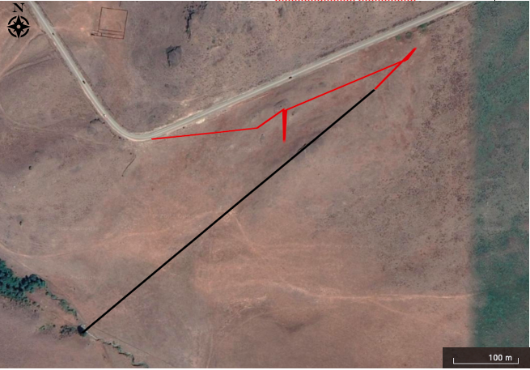
Figure 1. Telemetry for Sadie the Gophersnake. The end of the red and start of the black line shows where she was last located, and the black star indicates location of signal of confirmed mortality.
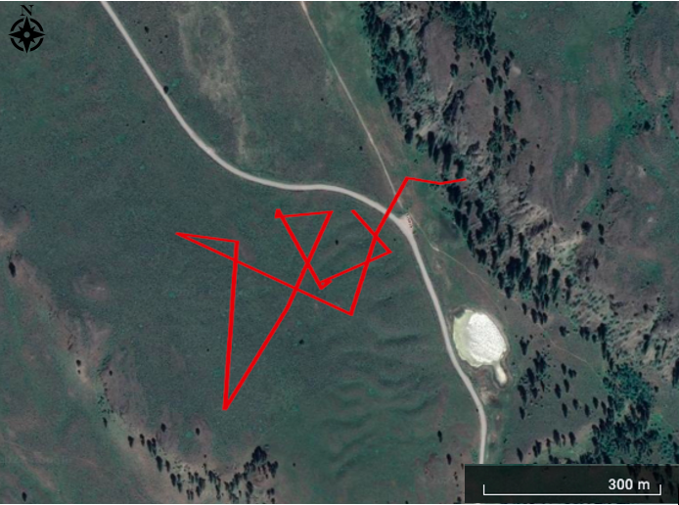
Figure 2. Telemetry of Blondie’s movement from leaving the den and into summer range.

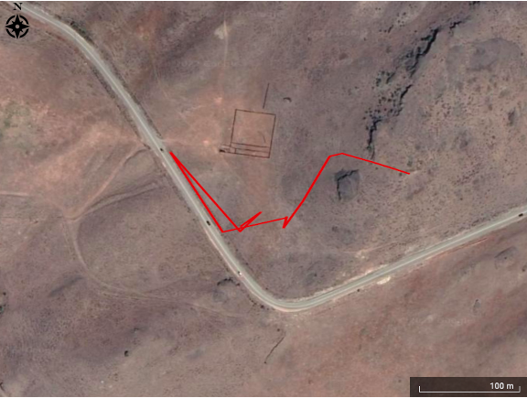
Figure 3. Telemetry of Marisol’s movement from leaving the den and into summer range.

Western Rattlesnakes
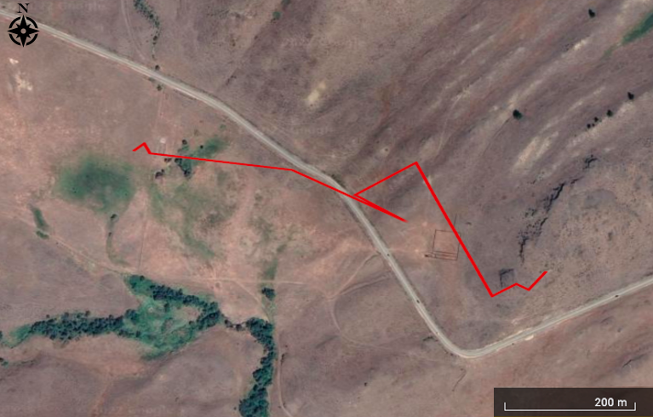
Figure 4. Telemetry of Tuco’s movement from leaving the den and into summer range.

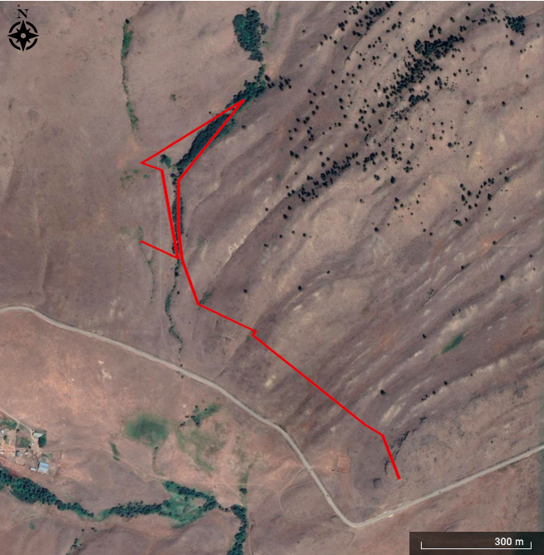

Figure 5. Telemetry of Teddy's movement from leaving the den and into summer range.

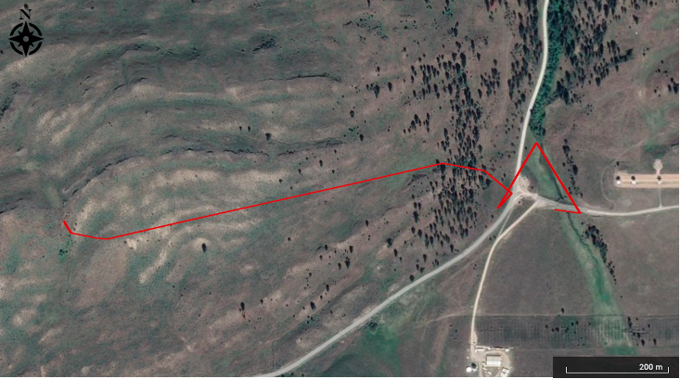
Figure 6. Telemetry of Gene's movement from leaving the den and into summer range.

Western Yellow-bellied Racers
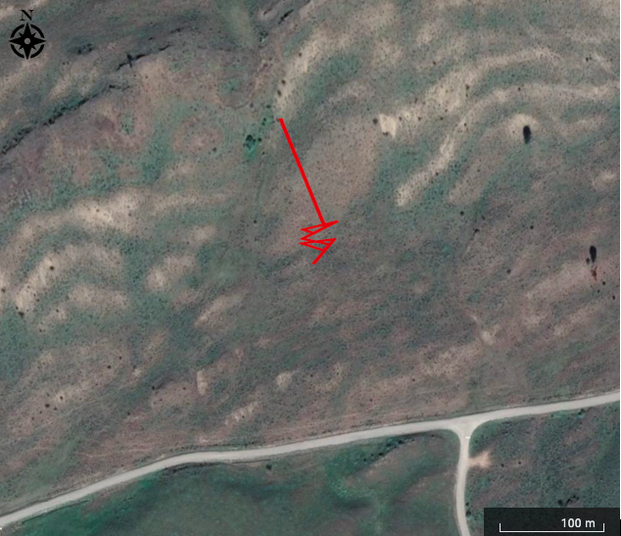
Figure 7. Telemetry of Chana's movement from leaving the den and into summer range.

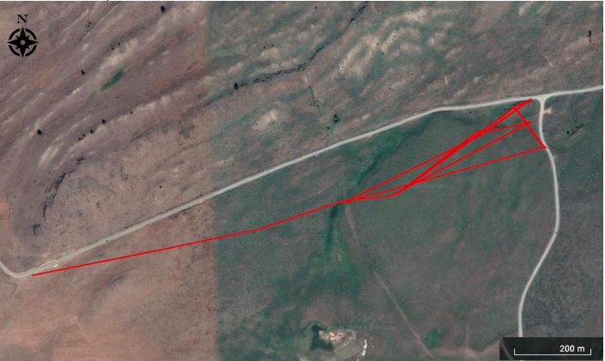
Figure 8. Telemetry of Mung's movement from leaving the den and into summer range.
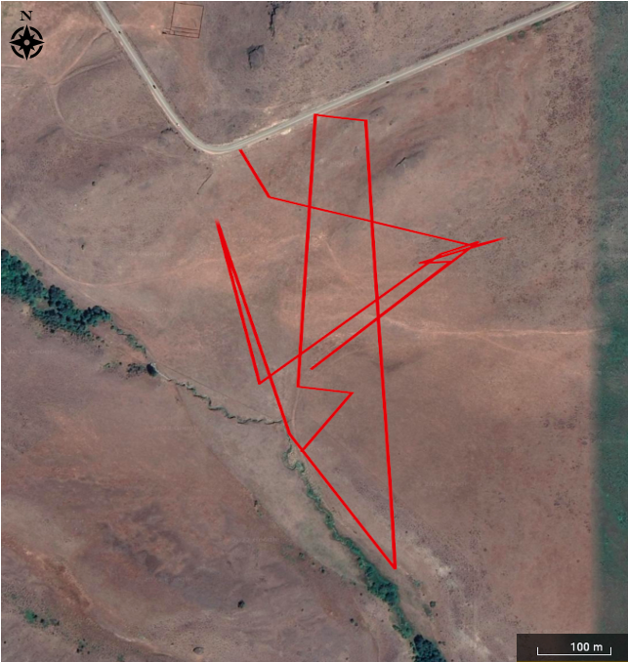
Figure 9. Telemetry of Pinto's movement from leaving the den and into summer range.

Table 3 Physical descriptions and telemetry information of each snake
Snake Name | Marisol | Tuco | Blondie | Mung | Pinto | Chana | Teddy | Gene
Sex | Female | Male | Male | Female | Female | Female | Male | Male
Species | Gopher snake | Gopher snake | Gopher snake | Racer | Racer | Racer | Rattlesnake | Rattlesnake
Start telemetry date | May 2, 2022 | May 11, 2022 | May 4, 2022 | April 24, 2022 | April 17, 2022 | May 5, 2022 | May 11, 2022 | May 1, 2022
End telemetry date | Unknown | Unknown | Unknown | Unknown | Unknown | Unknown | August 29, 2022 | August 29, 2022
Total days tracked | 21 | 20 | 27 | 22 | 24 | 18 | 22 | 21
Snout to vent length (cm) (SVL) | 90.2 | 107.3 | 96.8 | 70.3 | 71.8 | 63.7 | 80.0 | 62.0
First Weight (g) | 329 | 422 | 334 | 130 | 124 | 94 | 293 | 165

